**CloudFront Distribution using ALB 18-sep-23**

**Step1: Create a ec2 instance**

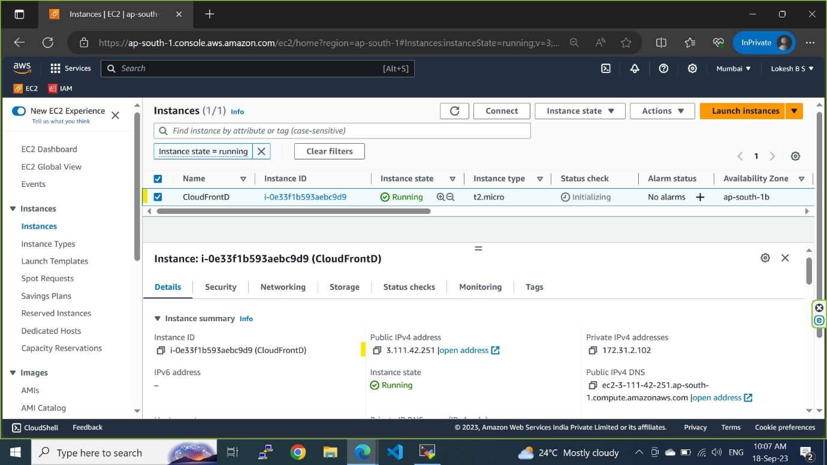

**step2 install https and create a index.html and add the content**

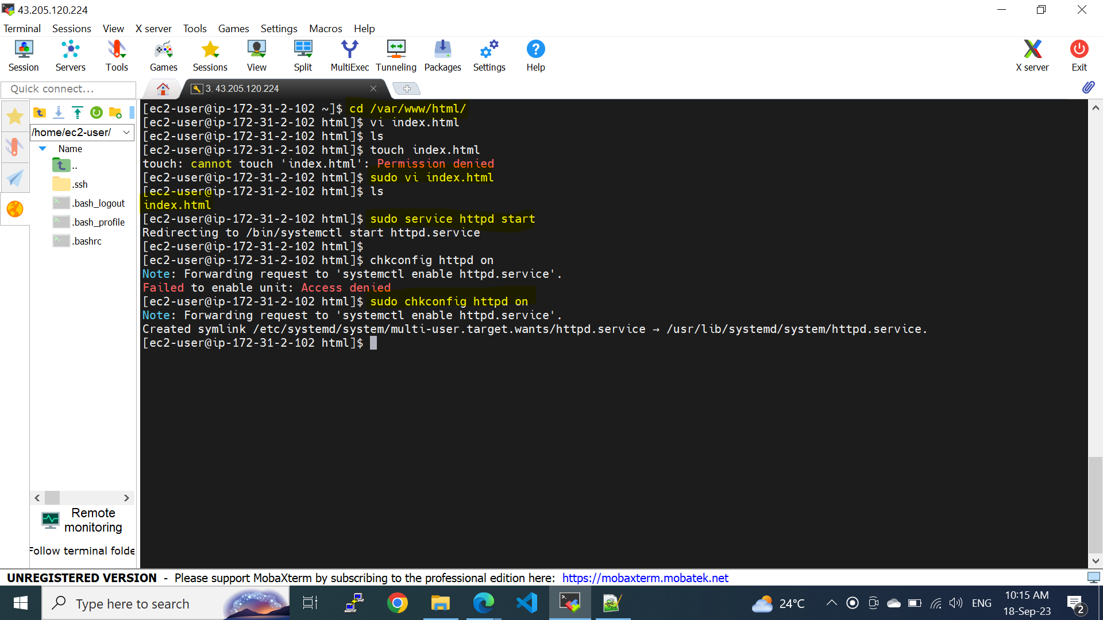

**step3 create a target group and click on next**

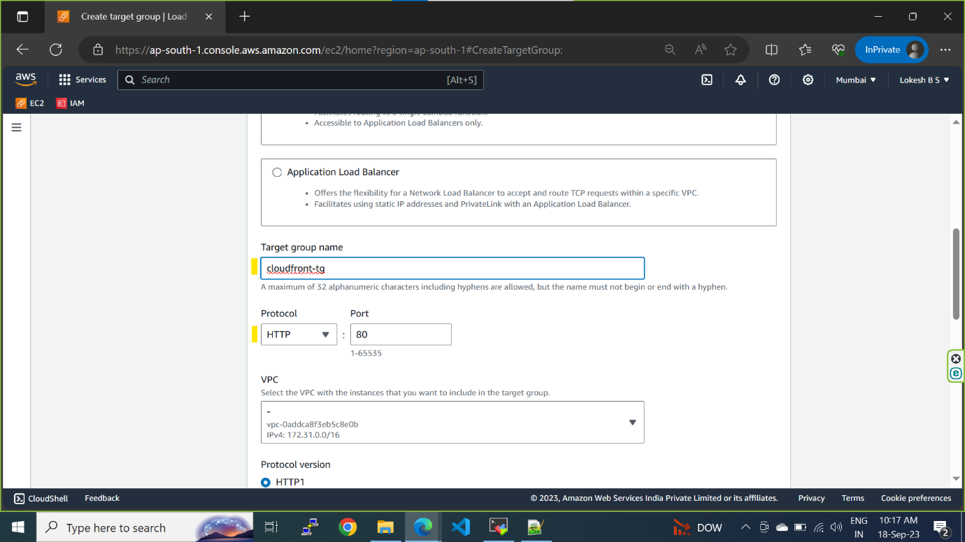

**step3a select the instance and include and click on create a target group**

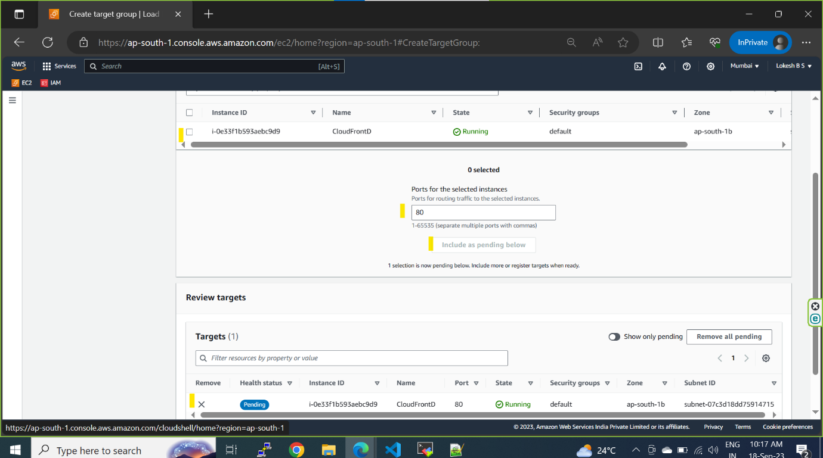

**step4 created target group and need to associate with load balancer**

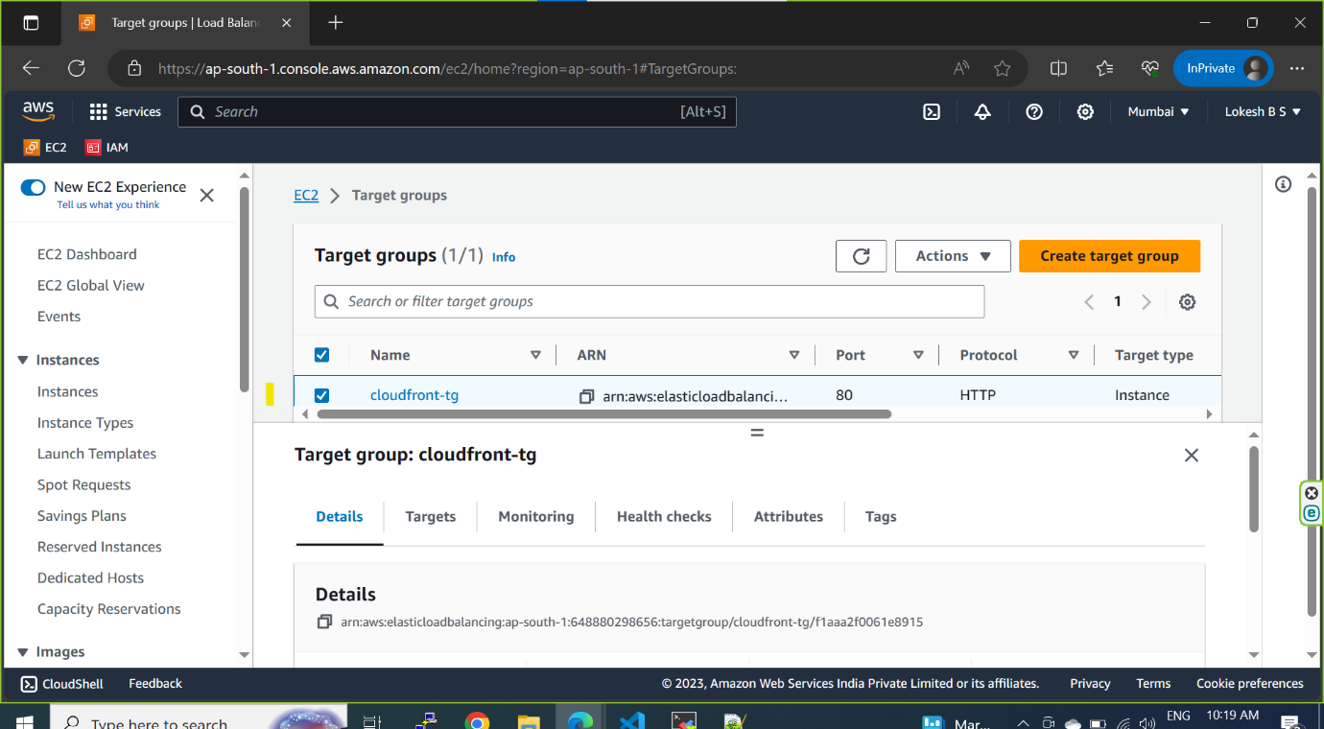

**step5 create a applicatioin load balancer**

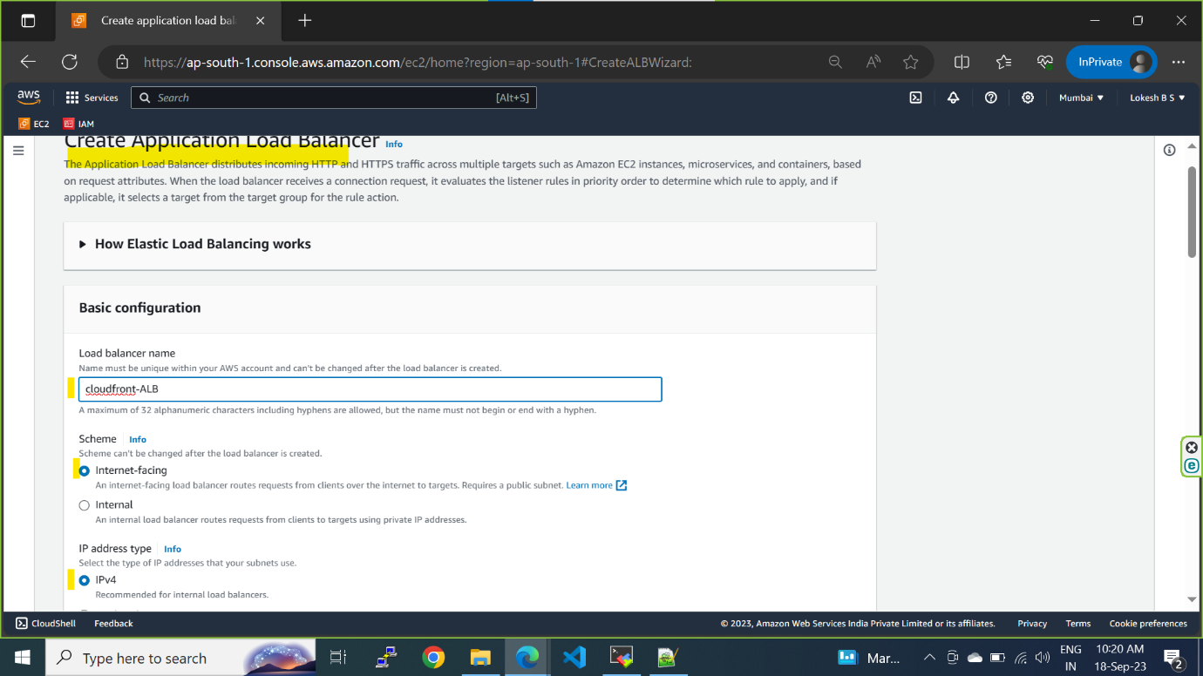

**step5a select the custome or default vpc and select the availibility zones**

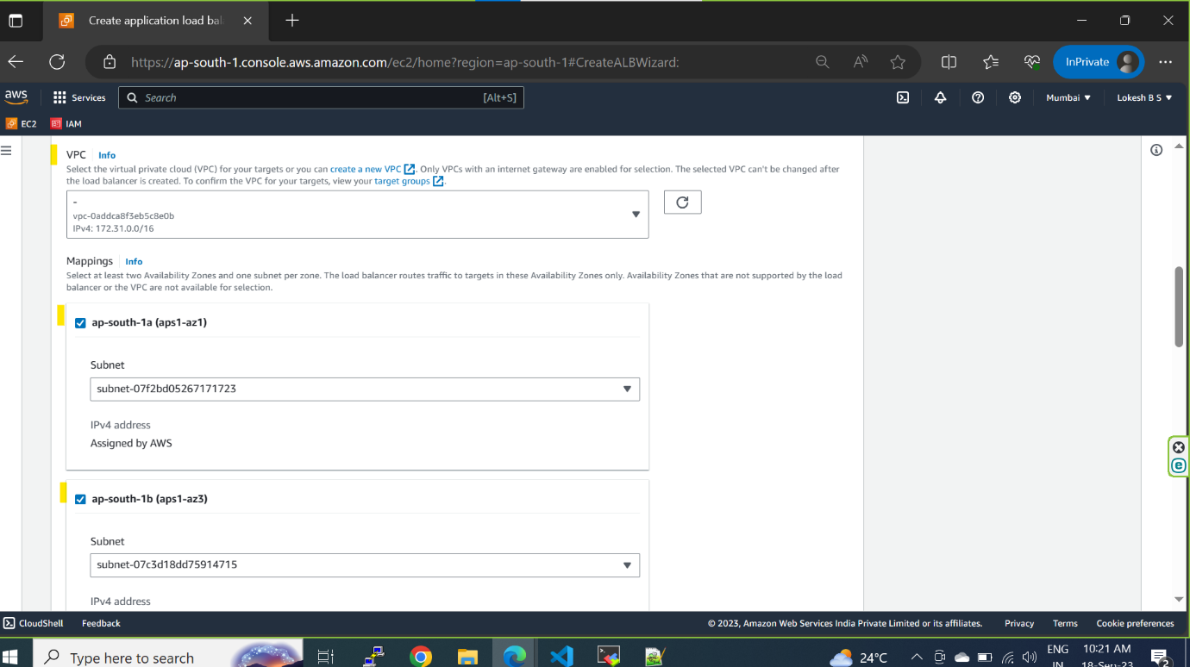

**step5b select the security group and target group**

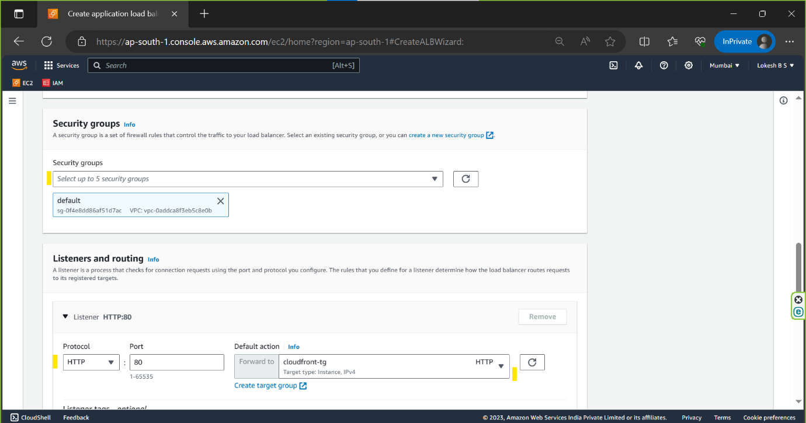

**step5c review and click on create load balancer**

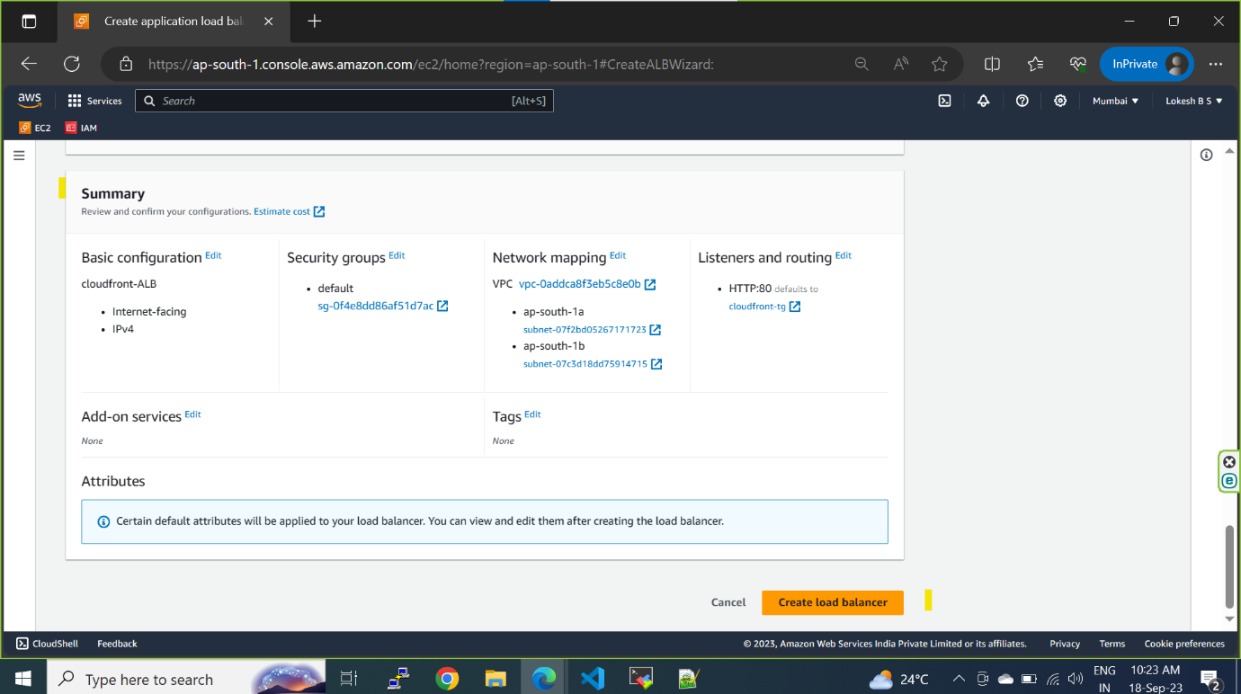

**step6 goto aws cloudfront and click on create a CloudFront distribution**

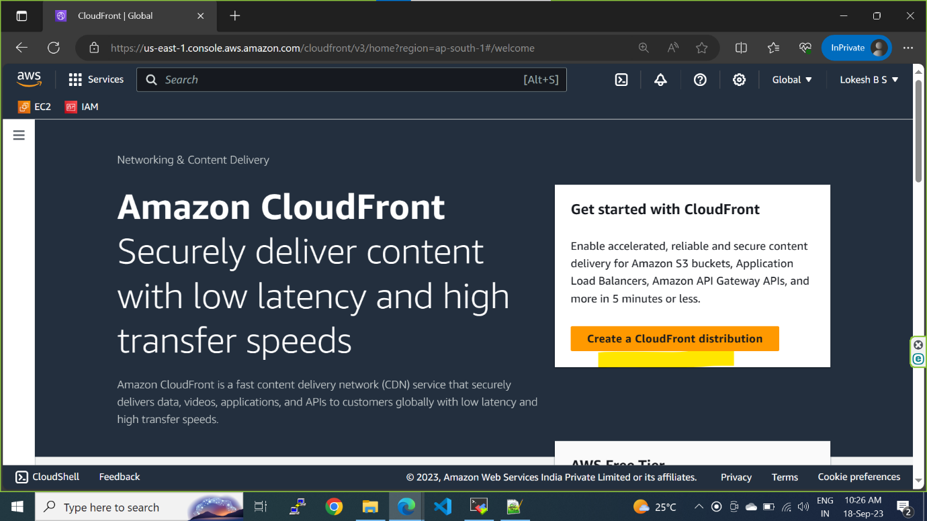

**step6a select the origin domain**

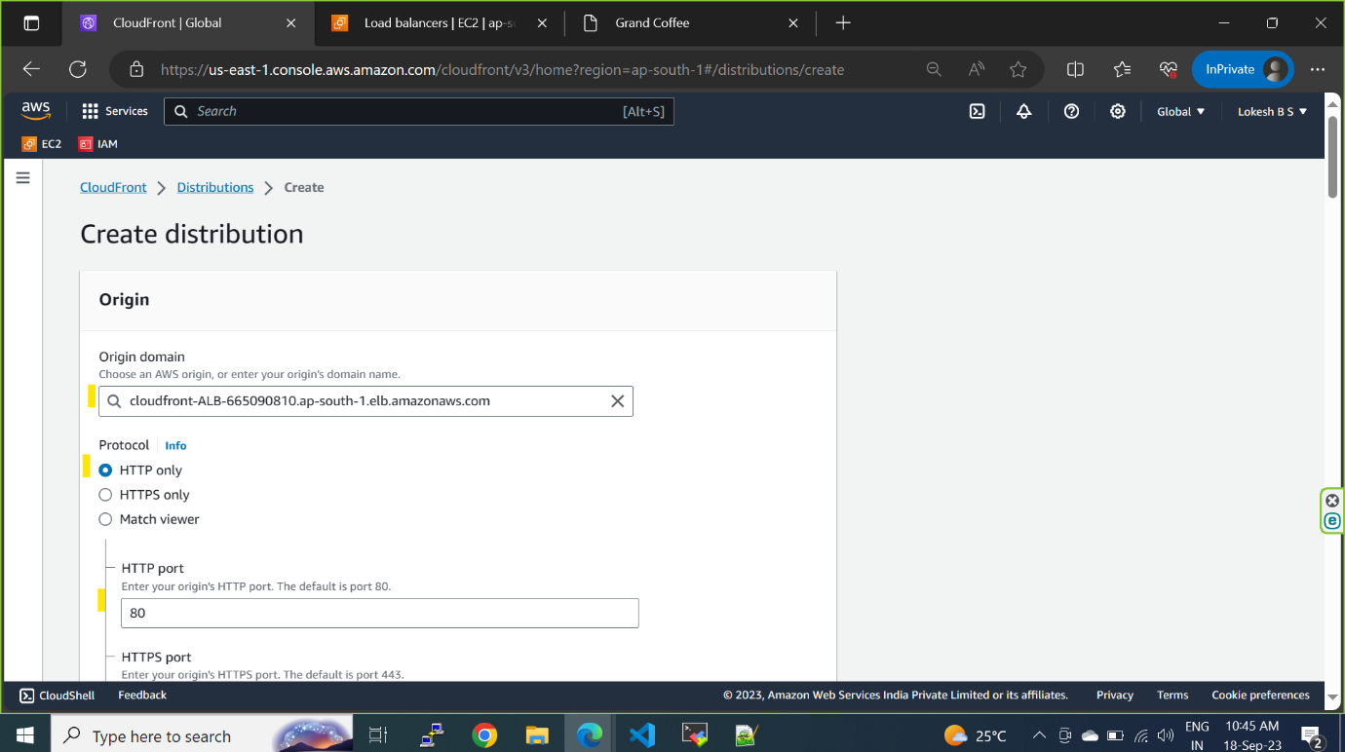

**step6b select the protocal**

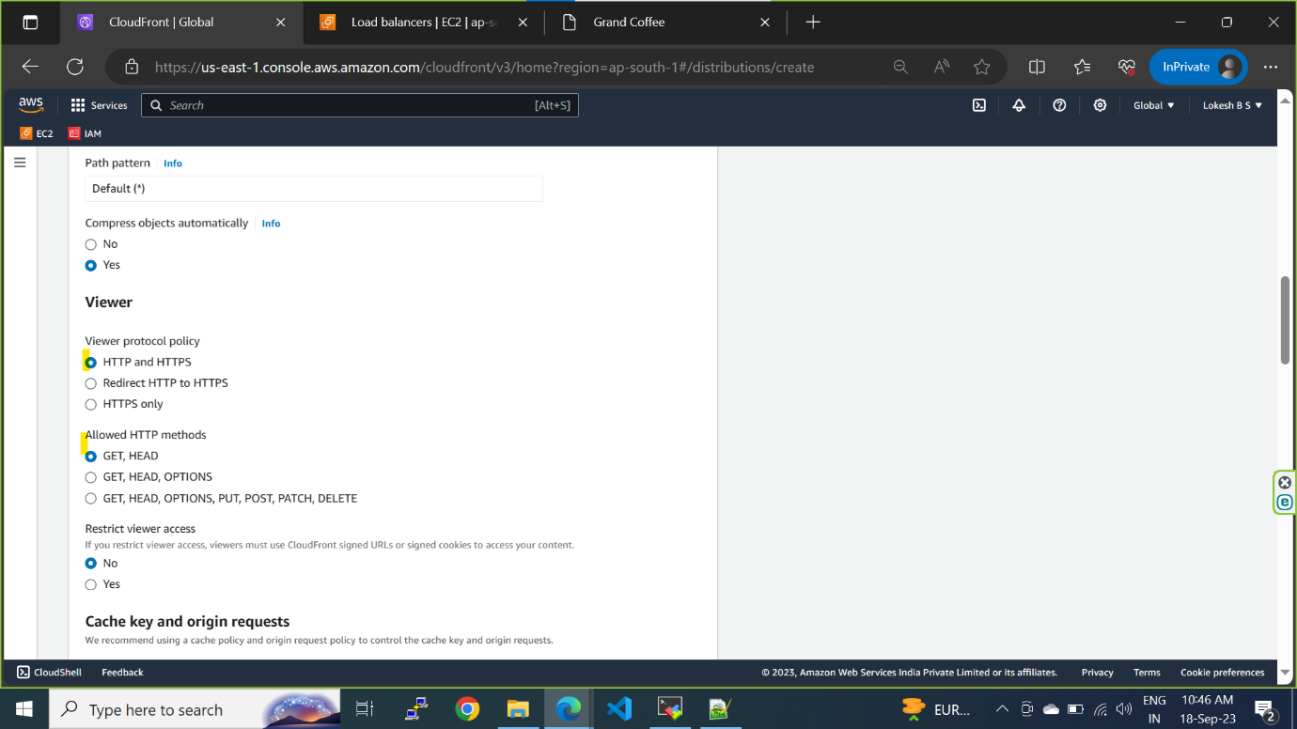

**step6c select the origin policy**

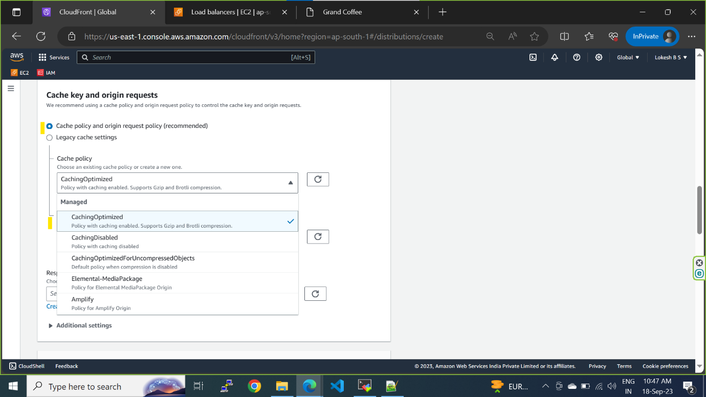

**step6d no WAF chargable and select price class**



**step6e cloudfront is created**

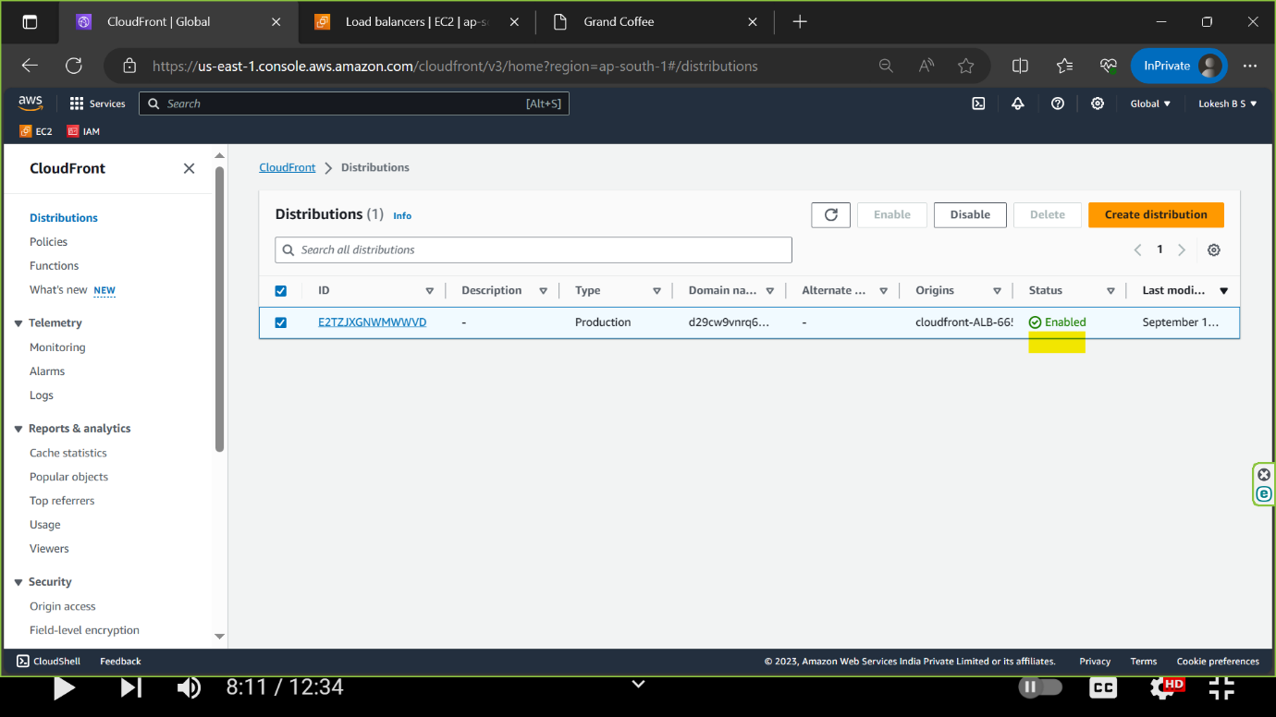

**step7 copy the distributed domain and paste it in browser**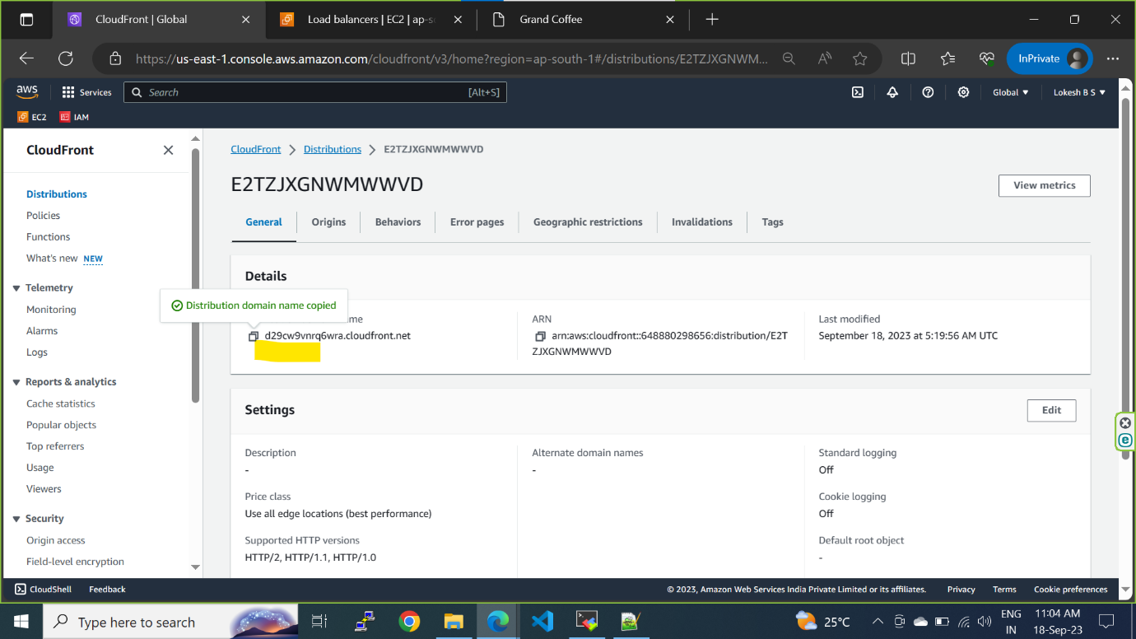

**step8 using cloudfront domain website accessed**

